Let’s Have a
Picnic!

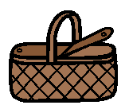

Copyright @ 2013 Peg Hutson-Nechkash, M.S., CCC-SLP
All Rights reserved by author
Permission to copy for single classroom use only

We are going to the park for a picnic.  We have fruit.  We have sandwiches.  We have juice.  We have vegetables.  Oh no! We have ants!  We have cupcakes.  Ants on the fruit!  Ants on the sandwiches!  Ants on the juice!  Ants on the vegetables!  Let’s go home.  Ants on the cupcakes! | The sun is shining.
Picnic Questions  Where do you like to have a picnic?  Who goes with you to a picnic?  What do you like to eat at a picnic?  When do you like to have a picnic?  Why is a picnic fun?  How can you keep ants away from your picnic? |  | On the next page, draw a picture of a fun picnic. Think about what you will eat, where the picnic will be, and who will be there. When you are finished, tell someone about your fun picnic.

Let’s Have a Picnic Images
Directions

Print out the following two pages on cardstock. Cut out and laminate. Attach Velcro dots to the back of each image. Enjoy!

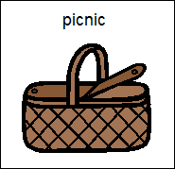

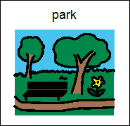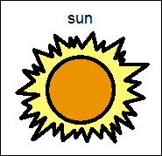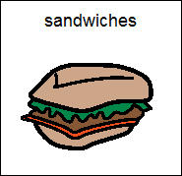
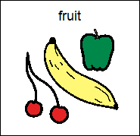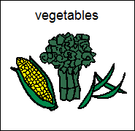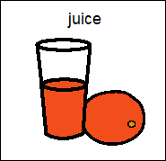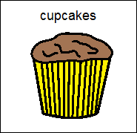
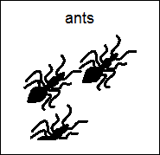

The Picture Communication Symbols ©1981-2010 by Mayer-Johnson LLC. All Rights Reserved Worldwide. Used with permission.
DynaVox Mayer-Johnson
2100 Wharton Street, Suite 400
Pittsburgh, PA 15203
Phone: 1 (800) 588-4548 Fax: 1 (866) 585-6260
Email: mayer-johnson.usa@mayer-johnson.com
Web site: www.mayer-johnson.com

